Java Basics & Pseudocode

LEGAL NAME LEONARD-ADRIAN BUNEA
PREFERRED NAME ZOE BUNEA
TIME SPENT XX:XX:XX
Table of Contents
Exercise 1 – Personal Information 2
Solution Idea 2
Code 2
Tests 2
Exercise 2 – Simple Calculator 3
Solution Idea 3
Code 3
Tests 3
Exercise 3 – Turtle Maze 3
Exercise 4 – Number Guessing 3

Exercise 1 – Personal Information

Solution Idea

Code
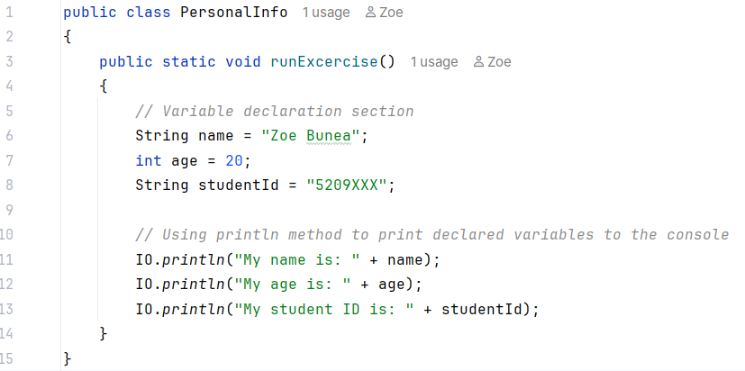
Figure 1: runExcercise method
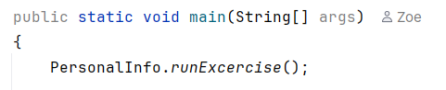
Figure 2: runExcercise being executed in main

Tests
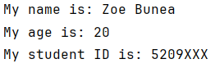
Figure 3: runExcercise console output

Exercise 2 – Simple Calculator

Solution Idea

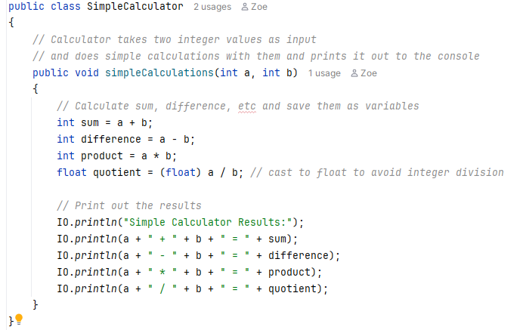
Code
Figure 4: SimpleCalculator class
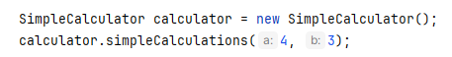
Figure 5: SimpleCalculator Example Usage

Tests
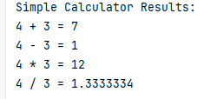
Figure 6: Simple Calculator Results

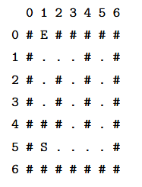
Exercise 3 – Turtle Maze
Figure 7: Turtle Maze Reference

Pseudocode

1 START
2 TURN RIGHT
3 FORWARD
4 FORWARD
5 TURN LEFT
6 FORWARD
7 FORWARD
8 FORWARD
9 FORWARD
10 TURN LEFT
11 FORWARD
12 FORWARD
13 TURN RIGHT
14 FORWARD

Trace Table
Line | Statement | Row | Col | direction
1 | START | 5 | 1 | north
2 | TURN RIGHT
3 | FORWARD
4 | FORWARD
5 | TURN LEFT
6 | FORWARD
7 | FORWARD
8 | FORWARD
9 | FORWARD
10 | TURN LEFT
11 | FORWARD
12 | FORWARD
13 | TURN RIGHT
14 | FORWARD

Exercise 4 – Number Guessing

Pseudocode

1 START
2

